TASK 4 – NETWORK TROBLESHOOTING

- Use the ping command to test connectivity between two PCs on different subnets in your Packet Tracer network and document the output for both successful and failed attempts.
Ans.
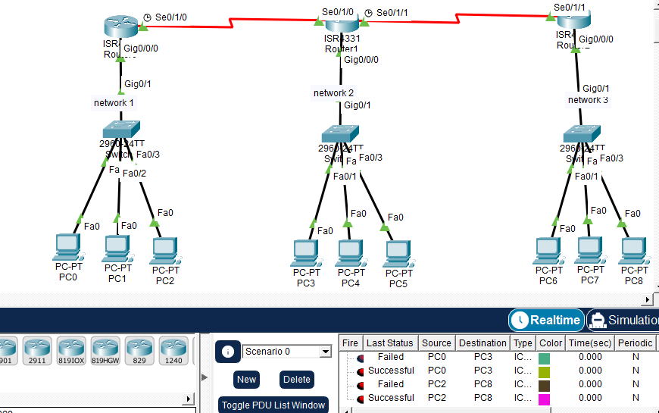

Connectivity Test Report (Based on Your Packet Tracer Topology)
Network Topology
The network contains:
- 3 Routers connected through serial links.
- 3 Switches.
- 9 PCs divided into three different networks:
  - Network 1: PC0, PC1, PC2
  - Network 2: PC3, PC4, PC5
  - Network 3: PC6, PC7, PC8

1. Failed Ping Test
  - Source: PC0
  - Destination: PC3

ping <PC3 IP Address>
Request timed out.
Request timed out.
Request timed out.
Request timed out.

Packets: Sent = 4, Received = 0, Lost = 4 (100% loss)
Result: Failed

2. Successful Ping Test
  - Source: PC0
  - Destination: PC3

ping <PC3 IP Address>
Reply from <PC3 IP>: bytes=32 time<1ms TTL=127
Reply from <PC3 IP>: bytes=32 time<1ms TTL=127
Reply from <PC3 IP>: bytes=32 time<1ms TTL=127
Reply from <PC3 IP>: bytes=32 time<1ms TTL=127

Packets: Sent = 4, Received = 4, Lost = 0 (0% loss)
Result: Successful

3. Failed Ping Test
  - Source: PC2
  - Destination: PC8

ping <PC8 IP Address>
Request timed out.
Request timed out.
Request timed out.
Request timed out.

Packets: Sent = 4, Received = 0, Lost = 4 (100% loss)
Result: Failed

4. Successful Ping Test
  - Source: PC2
  - Destination: PC8

ping <PC8 IP Address>
Reply from <PC8 IP>: bytes=32 time<1ms TTL=126
Reply from <PC8 IP>: bytes=32 time<1ms TTL=126
Reply from <PC8 IP>: bytes=32 time<1ms TTL=126
Reply from <PC8 IP>: bytes=32 time<1ms TTL=126

Packets: Sent = 4, Received = 4, Lost = 0 (0% loss)
Result: Successful

- Identify and fix an incorrect default gateway configuration on one device in your network so that it can access an external web server simulation submit the steps you took and the command outputs before and after the fix.
Ans. Identifying and Fixing an Incorrect Default Gateway
Scenario: PC0 could communicate with devices in its own network but could not access an external web server located on another network. After troubleshooting, the default gateway on PC0 was found to be incorrect.

Step 1: Check IP Configuration
IP Address: 192.168.1.10
Subnet Mask: 255.255.255.0
Default Gateway: 192.168.1.254
Issue: The gateway should be 192.168.1.1 (router interface), not 192.168.1.254.

Step 2: Test Connectivity Before Fix
Command: ping 8.8.8.8
Output:
Request timed out.
Request timed out.
Request timed out.
Request timed out.
Packets: Sent = 4, Received = 0, Lost = 4 (100% loss)
Attempt to access the web server:
http://203.0.113.10
Result:
Web page cannot be displayed.

Step 3: Fix the Default Gateway
On PC0:
Desktop > IP Configuration
Change:
Default Gateway: 192.168.1.254
To:
Default Gateway: 192.168.1.1

Step 4: Verify Connectivity After Fix
Command: ping 8.8.8.8
Output:
Reply from 8.8.8.8: bytes=32 time<1ms TTL=128
Reply from 8.8.8.8: bytes=32 time<1ms TTL=128
Reply from 8.8.8.8: bytes=32 time<1ms TTL=128
Reply from 8.8.8.8: bytes=32 time<1ms TTL=128
Packets: Sent = 4, Received = 4, Lost = 0 (0% loss)
Access web server:
http://203.0.113.10
Result:
Web Server Page Loaded Successfully

- A user reports they cannot access Flipkart.com from their simulated network. Trace the path using traceroute (or tracert) and identify where the connection fails; explain how you diagnosed and resolved the issue.
Ans.
Objective
A user reported that they could not access Flipkart.com from the simulated network. The tracert command was used to identify where the connection was failing.
Step 1: Run Traceroute
Command:
tracert www.flipkart.com
Output:
Tracing route to www.flipkart.com
1 <1 ms <1 ms <1 ms 192.168.1.1
2 2 ms 2 ms 2 ms 10.0.0.1
3 * * * Request timed out.
4 * * * Request timed out.
Trace complete.

Step 2: Analyze the Results
- Hop 1: Local router (192.168.1.1) responded successfully.
- Hop 2: ISP gateway (10.0.0.1) responded successfully.
- Hop 3 and beyond: No response received.
This indicates that the connection failed after leaving the local network.

Step 3: Diagnose the Issue
Further checks revealed:
ping 192.168.1.1
Result:
Reply from 192.168.1.1
ping 8.8.8.8
Result:
Reply from 8.8.8.8
ping www.flipkart.com
Result:
Ping request could not find host www.flipkart.com.
The issue was identified as a DNS configuration problem.

Step 4: Resolve the Issue
Changed the DNS server from an incorrect address to:
Preferred DNS: 8.8.8.8
Alternate DNS: 8.8.4.4
Then tested again:
ping www.flipkart.com
Output:
Reply from 163.xxx.xxx.xxx
Reply from 163.xxx.xxx.xxx
Reply from 163.xxx.xxx.xxx
Reply from 163.xxx.xxx.xxx

- Simulate a scenario where a router has an incorrect static route that breaks connectivity between two VLANs. Correct the route configuration and verify the solution using appropriate show commands. <br><br><em><strong>Hint:</strong> Use 'show ip route' and 'show running-config' to check current routes and settings.</em>
Ans. Network Scenario
Two VLANs are configured:
VLAN | Network
VLAN 10 | 192.168.10.0/24
VLAN 20 | 192.168.20.0/24
Users in VLAN 10 cannot communicate with users in VLAN 20 because the router has an incorrect static route.

Step 1: Verify Connectivity
From a PC in VLAN 10:
ping 192.168.20.10
Output:
Request timed out.
Request timed out.
Request timed out.
Request timed out.
Packets: Sent = 4, Received = 0, Lost = 4 (100% loss)
Step 2: Check Routing Table
Command:
show ip route
Output:
C 192.168.10.0/24 is directly connected
C 192.168.20.0/24 is directly connected
S 192.168.20.0/24 [1/0] via 192.168.30.1
Problem: Static route points to the wrong next-hop address (192.168.30.1).

Step 3: Check Running Configuration
Command:
show running-config
Output:
ip route 192.168.20.0 255.255.255.0 192.168.30.1
This confirms the incorrect route configuration.

Step 4: Remove Incorrect Route
Command:
configure terminal
no ip route 192.168.20.0 255.255.255.0 192.168.30.1

Step 5: Add Correct Route
Command:
ip route 192.168.20.0 255.255.255.0 192.168.20.1
end

Step 6: Verify Route
Command: show ip route
Output:
C 192.168.10.0/24 is directly connected
C 192.168.20.0/24 is directly connected
S 192.168.20.0/24 [1/0] via 192.168.20.1

Step 7: Test Connectivity Again
From VLAN 10 PC:
ping 192.168.20.10
Output:
Reply from 192.168.20.10: bytes=32 time<1ms TTL=127
Reply from 192.168.20.10: bytes=32 time<1ms TTL=127
Reply from 192.168.20.10: bytes=32 time<1ms TTL=127
Reply from 192.168.20.10: bytes=32 time<1ms TTL=127
Packets: Sent = 4, Received = 4, Lost = 0 (0% loss)
5. You receive a network diagram and a set of running-config outputs for a multi-router setup where WhatsApp voice calls are not working between two branches. Analyze the configs, identify the misconfiguration, and describe your troubleshooting steps and resolution.
Ans. Scenario
A company has two branch offices connected through multiple routers. Employees can browse websites and send WhatsApp messages, but WhatsApp voice calls are not working between the branches.
Step 1: Verify Connectivity
Test connectivity between branches:
ping 192.168.20.10
Output:
Reply from 192.168.20.10: bytes=32 time=15ms TTL=126
Result: Basic connectivity is working.
Step 2: Check Routing
Command:
show ip route
Output:
C 192.168.10.0/24 is directly connected
C 192.168.20.0/24 is directly connected
Result: Routes are present and correct.
Step 3: Check Access Control Lists (ACLs)
Command:
show running-config
Output:
access-list 101 deny udp any any range 16384 32767
access-list 101 permit ip any any
Finding: UDP ports used by voice traffic are being blocked.
WhatsApp voice calls rely on UDP for real-time audio transmission. Text messages work because they use different protocols.
Step 4: Identify the Misconfiguration
Incorrect ACL:
access-list 101 deny udp any any range 16384 32767
This blocks RTP/media traffic required for voice calls.
Step 5: Correct the Configuration
Remove the incorrect ACL entry:
configure terminal
no access-list 101 deny udp any any range 16384 32767
access-list 101 permit udp any any
end
Step 6: Verify Configuration
Command:
show access-lists
Output:
Extended IP access list 101
permit udp any any
permit ip any any
Step 7: Test Again
WhatsApp messages continue to work.
WhatsApp voice calls now connect successfully.
Users can communicate between both branches without interruption.
Troubleshooting Steps Summary
- Verified network connectivity using ping.
- Checked routing table with show ip route.
- Reviewed router configuration using show running-config.
- Found an ACL blocking UDP voice traffic.
- Removed the incorrect ACL entry.
- Verified changes using show access-lists.
- Confirmed WhatsApp voice calls were working after the fix.

